Shubham Rawat
MCA 2020-2022
DBMS Assignment 4
1.Retrieve a list of MANAGERS.
select ename,job from emp where job ='MANAGER';
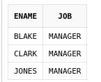

2. Find out salary of both MILLER and SMITH.
select ename,sal from emp where ename ='JAMES' or ename = 'MILLER';
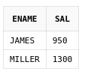

3. Find out the names and salaries of all employees earning more than 1000 per month
select ename,sal from emp where sal >=1000;
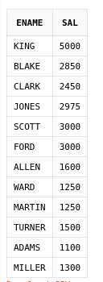

4. Display the names and salaries of all employees except JAMES and MILLER
select ename,sal from emp where not ename in('JAMES','MILLER') ;
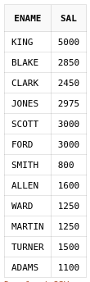

5. List the name and salary of employees who can earn more than 1500 and are in
department 10 or 30. Label the columns Employee and Monthly Salary respectively.
select ename,sal from emp where sal >=1500 and deptno in(10,30);
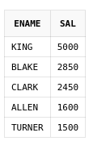

6. List the name and salary for all employees whose salary is not in the range of 1500 and2850.
select ename,sal from emp where not sal between 1500 and 2850;
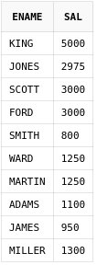

7. Display the name, job, and salary of all the employees whose job is CLERK or ANALYST and their salary is not equal to 1000, 3000, or 5000.
select ename,job,sal from emp where not sal in (1000,5000,3000) and job in('CLERK','ANALYST');
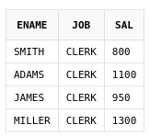

8. Display the name, salary and commission for all employees whose commission
amount is greater than their salary increased by 10%.
select ename,sal,comm from emp where comm >= 1.1*sal;
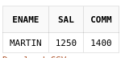

9. Display the name of all employees who have two Ls in their name and are in
department 30 or their manager is 7782.
select * from emp where ename like '%L%L%' and deptno = 30 or mgr = 7782;
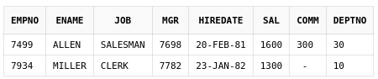

10. Find out the details of employees whose names begin with ‘S’.
select * from emp where ename like 'S%';
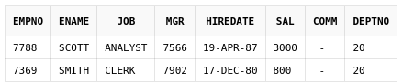

11. Find out the names of all employees that have ‘A’ anywhere in their name.
select * from emp where ename like '%A%';
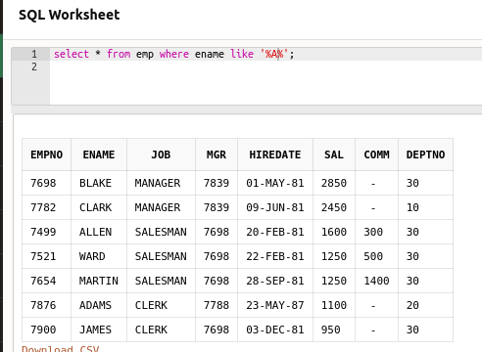

12. Find out the names of all employees that have ‘L’ as their third character in their
Name.
select * from emp where ename like '__L%';
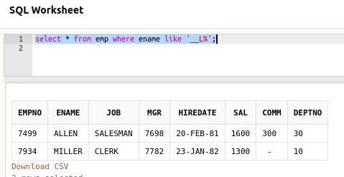

13. Find out the names of the employees whose name begin with ‘A’ or ‘M’.
select * from emp where ename like 'A%' or ename like 'M%';
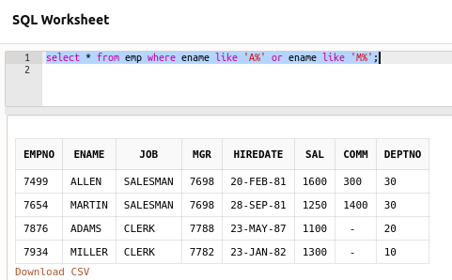

14. List all the employees whose commission is NULL.
select empno "Employee No.", ename "Name", comm "Commission" from emp where comm is NULL;
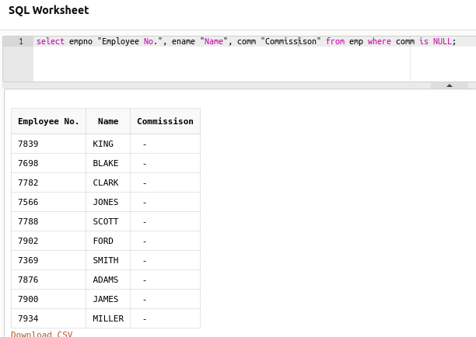

15. List employee number, employee name, total salary (i.e. salary +commission). (Note:
Manipulate the NULL values accordingly.)
select empno "Employee No.", ename "Name", coalesce(sal+comm,sal,comm) "Salary" from emp;
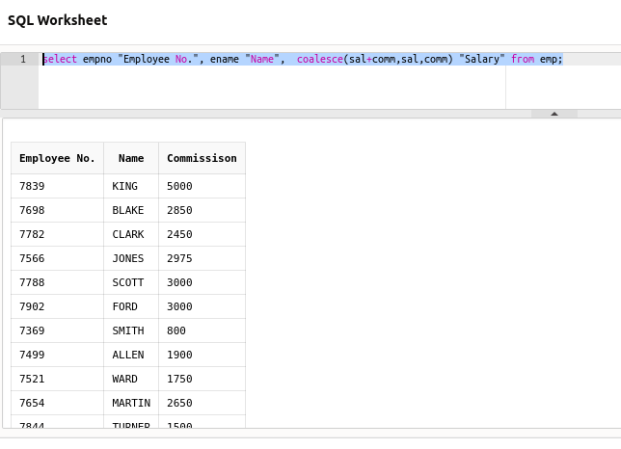
16. List the name of the employee and designation of the employee, who does not
report to anybody.
select ename "Name",job "Designation" from emp where mgr is null;
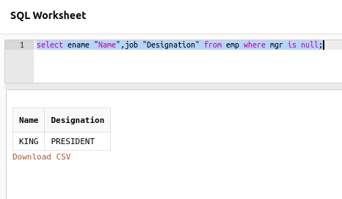

17. List employee name and yearly salary and arrange the output on the basis of yearly salary in descending order.
select ename "name" , sal*12 "yearly salary" from emp order by sal desc;
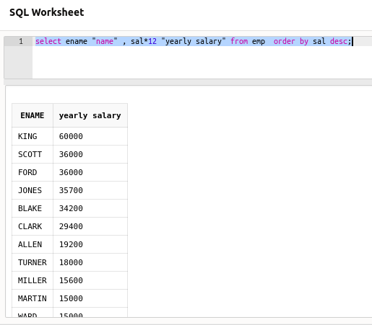

18. Retrieve the names of departments in ascending order and their employees in
descending order.
select dname, ename from dept join emp on dept.deptno = emp.deptno order by dname,ename desc ;
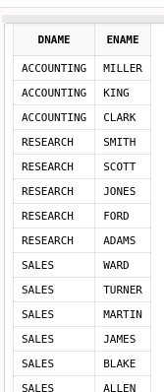

19. Select the name, job, salary, and department number of all employees except
SALESMAN from department number 30.
select ename, job, sal, deptno from emp where not (deptno= 30 and job = 'SALESMAN');
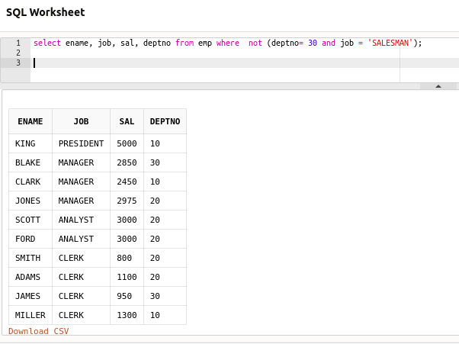

20. List different jobs with no duplicates.
select DISTINCT job from emp ;
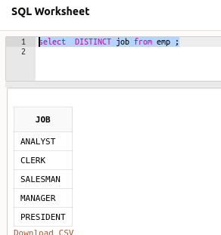

21. Count the total number of employees.
select count(empno) as employee_No from emp ;
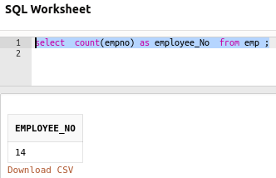

22. Print the total employees and average salary of each department.
select deptno, count(deptno),avg(sal) from emp group by deptno;
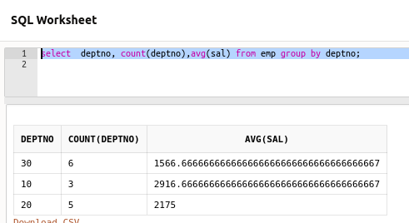

23. Select the minimum and maximum salary from EMP table.
select MIN(sal) as MinmumSalary, MAX(sal) as MaximumSalary from emp;
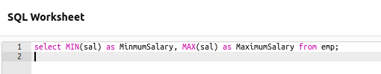
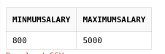

24. List the minimum and maximum salaries of each department.
select deptno, Max(sal) as "Maximum Salary",Min(sal) as "Minimum Salary" from emp group by deptno;
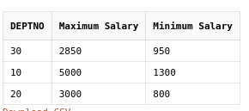

25. List all departments in which more than 3 employees are working.
SELECT deptno ,count(empno) FROM emp group by deptno having COUNT(*) > 3;
